**DAY – 4**

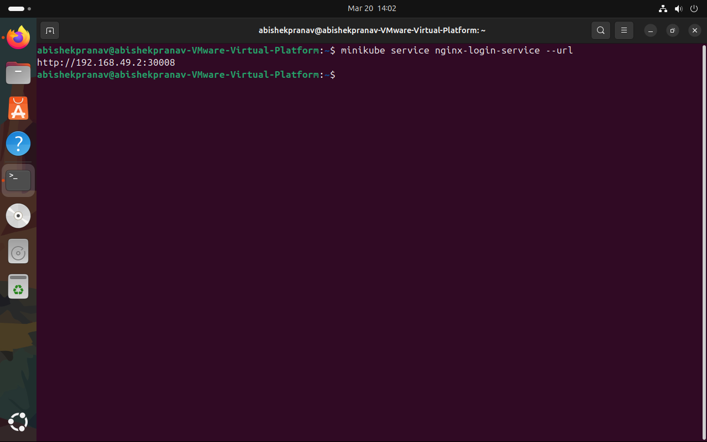

**Command** : minikube service nginx-login-service --url

**Explanation :**

This command retrieves the external URL for the nginx-login-service running in your Minikube cluster.